Electronic Supplementary Information

An Unprecedented Square Planar Fe(III) Complex Exhibiting Spin Crossover Between the Spin-Admixed States
Kamal Uddin Ansari,^{# a} Dipanti Borah,^{# a} Lena Spillecke,^{b} Kavipriya Thangavel,^{d} Pardeep Kumar,ª Purva Dua,ª Sourav Dey,ª Rüdiger Klingeler,^{b} Martin Clémancey,^{c} Amaleswari Rasamsetty,ª Stephen Hill,*^{e} Geneviève Blondin,*^{c} Gopalan Rajaraman,*ª and Maheswaran Shanmugam*ª

ªDepartment of Chemistry, Indian Institute of Technology Bombay, Powai, Mumbai-400076 Maharashtra India,
^{b}Kirchhoff Institute for Physics, Heidelberg University, 69120 Heidelberg, Germany
^{c}Univ. Grenoble Alpes, CNRS, CEA, IRIG, Laboratoire de Chimie et Biologie des Métaux,, 17 rue des Martyrs, 38000 Grenoble (France)
^{d} National High Magnetic Field Laboratory, Florida State University, Tallahassee, Florida 32310
^{e} National High Magnetic Field Laboratory, Florida State University, Tallahassee, Florida 32310, United States; Department of Physics, Florida State University, Tallahassee, Florida 32306, United States; Department of Chemistry and Biochemistry, Florida State University, Tallahassee, Florida 32306, United States,
# These authors contributed equally
*Corresponding authors: eswar@chem.iitb.ac.in (MS); rajaraman@chem.iitb.ac.in (GR); genevieve.blondin@cea.fr; (GB) shill@magnet.fsu.edu (SH)

Table of Contents
- Experimental Section
Materials and Methods ………………………………………………………………….….. S5
Computational Section ……………………………………………………………………... S6
Synthetic procedure for ligand L1 ……………………………………………………….. S6
Scheme S1. General method followed to isolate L1 …………………………….… S7
Figure S1. ESI-MS of ligand L1 ………………………………………………………………… S7
Figure S2. Cyclic Voltametry curve of reduction of ligand L1 ……………..…… S8
General procedure for the synthesis of
compound Na(DME)₃[Fe(L1)₂] (1) ..…………………………………………….. S8
- Figure S3. Thermal ellipsoid picture of the asymmetric unit of 1 …………………….. S9
- Table S1. Crystallographic information of 1 at 100-300 K ………………………………… S9
- Structural description of 1 (collected at 100 K) ………………………………………………… S10
- Scheme S2. The general reaction scheme to isolate a five-coordinate Fe(III) complex [Fe(L1^{•-})₂Cl] by changing the reaction condition slightly from 1 …………………………. S10
- Figure S3A. Crystal structure of [Fe^{III}(L^{•-})₂Cl] complex……………………………………….. S11
- Table S2. Selected bond lengths and bond angles of 1 recorded at 100 K ……..…. S11
- Table S3. Continuous shape measure deviation (CShM) of 1 ………………………….... S11
- Scheme S3. Change in the structural parameters noticed upon
various levels of reduction of the ligand L1 (neutral = black trace;
1e reduced = Blue trace; 2e reduced = green trace) along with the
structural parameters observed for the L1 ligand (red trace) in complex 1 ……... S12
- Figure S4. Powder X-ray diffraction pattern of the complex 1 …………………………. S12
- Figure S5. Superimposition of the zero-field experimental spectra
of 1 recorded at ca 6 (black) and 80 K (blue) scaled to the same area ……………… S13
- Table S4. Linewidths and relative contributions of the slow- and
fast-relaxing systems used to reproduce the Mössbauer spectra when …………… S13
assuming an effective spin of S=1/2
- Figure S6. Experimental Mössbauer spectra recorded on a powder sample
of 1 at ca 6 (A–E) and 80 K (F-J) at zero-field (A and F) or with a 0.06 (B and G),
1 (C and H), 4 (D and I) and 7 T (E and J) magnetic field applied parallel to the
γ-rays (vertical bars) ……..…………………………………………………………………………….….. S14
12. Table S5. Common electronic and nuclear parameters used to reproduce
the 6 and 80 K spectra. An S=3/2 state was assumed ………………………………………. S14
- Table S6. Linewidths and relative contributions of the slow and fast
Relaxing systems used to reproduce the Mössbauer spectra assuming ………….. S15
a S=3/2 spin state
- Figure S7. Experimental (vertical bars) of the ca 6 K Mössbauer spectra
of 1 recorded with a 0.06 (A) and 1 T (B) external magnetic field applied ………. S15
parallel to the γ-rays
- Figure S8. Experimental (vertical bars) of the ca 6 K Mössbauer spectra
of 1 recorded with a 0.06 (A) and 1 T (B) external magnetic field applied ………. S16
parallel to the γ-rays.
- Figure S9. Variable temperature X-Band EPR for polycrystal sample of 1 ……..… S16
- Figure S10. The spin-crossover phenomenon observed in Fe(III) system
in various coordination geometry. Octahedral (O_{h}), Square Pyramidal ……..… S17
(Spy), Trigonal Bipyramidal (TBP), and Square Planar (SP)
- Table S7. Selected bond length and bond angle of 1 collected in the ………….….. S17
temperature range 100-300 K
- Figure S11. The unit cell parameters in 1 as a function of temperature …………. S18
- Figure S12. The optimized geometry of sextet (left), quartet (middle) …………... S18
and doublet (right) spin state of 1
- Table S8. Benchmarking of different functionals for complex 1, …………………….. S18
comparing the energies of S=5/2, 3/2, and 1/2 spins
- Figure S13. a) d_{xz} orbital (left) of Fe metal center having no second-order
perturbation interaction with attached ligand atoms, d_{yz} orbital of Fe
metal center having two σ antibonding interactions with two oxygen
atoms (middle and right), b) Optimised structure of quartet showing
non-covalent interactions between C-H•••Fe bond, c) AIM plot for 1 …………… S19
showing Bond critical points by red spheres
Table S9. The optimized structural parameters of 1 for sextet, quartet
and doublet spin states ………………………………………………………………………………….. S19
- Figure S14. The spin density (iso-surface value 0.006 e⁻/bohr³) of sextet ……..… S20
(left), quartet (middle) and doublet (bottom) spin state of 1
- Table S10. The spin density values of Fe and its first coordination sphere …..…. S20
atoms in 1 for sextet, quartet and doublet spin states
- Table S11. Benchmarking of different functionals for the S = 3/2 state ……….…. S20
in complex 1 to calculate the Mössbauer parameter, isomer shift (δ)
- Table S12. Relative Energies (in eV) of Fe orbitals with different ………………….… S21
functionals for quartet state of complex 1
- Table S13. The CAS(7,6)SCF/NEVPT2 transition energy of the ………………………... S21
ligand field states of 1
- Table S14. The major electronic configurations of the first nine …………….………. S22
states from the CAS(7,6)SCF/NEVPT2 calculations on 1
- References ……………………………………………………………………………………………….…….. S22

Experimental Section:
Materials and methods. Unless otherwise mentioned, all the reactions were carried out under anaerobic conditions either using a glove box (Argon atmosphere) and Schlenk line techniques. Ligand L1 was synthesized following the literature procedure.^{[1]} Single-crystal data were collected using a graphite monochromator on a Rigaku Saturn CCD diffractometer (MoK_{α}, λ = 0.71073 Å). The selected crystals were mounted on the tip of a glass pin using parafin oil and placed in the cold flow produced with an Oxford Cryo-cooling device. Structure solution and refinement were performed with the SHELX-package.^{[2]} The structures were solved by direct methods and completed by iterative cycles of ΔF syntheses and full-matrix least-squares refinement against F² (CCDC: 2383943 (for 100 K data), 2383909 (for 300 K data)). The elemental analyses (C, H, and N) were performed on a Thermoquest micro-analyzer and the sample was prepared under an argon atmosphere inside a glovebox. Then this sample was transferred to the instrument before measurement with the help of an air-tight glass tube. PXRD measurement has been performed on powdered samples in a Rigaku D/tex Ultra 250 instrument using Cu K_{β} filter with a scan speed of 4°/min at room temperature using an airtight sample holder. The Mössbauer spectra were recorded at ca. 5 K on a strong-field Mössbauer spectrometer equipped with an Oxford Instruments Spectromag 4000 cryostat containing an 8 T split-pair superconducting magnet. The spectrometer was operated in a constant acceleration mode in transmission geometry. The isomer shifts were referenced against that of a room-temperature metallic iron foil. Analysis of the data was performed with a homemade program.^{[3]} Before measurements samples were sent to Grenoble in sealed phials and stored in a glovebox upon arrival. Cups were prepared inside the glovebox, sealed with wax, and then transferred out of the glovebox in a flask filled with Ar, which was placed and opened in liquid nitrogen. A helium atmosphere was maintained during the room temperature measurements. The dc susceptibility and magnetization measurements were performed using a magnetic property measurement system (MPMS3) provided by Quantum Design, which is equipped with a 70 kOe superconducting magnet. Samples were prepared under Ar atmosphere inside the glovebox in a pressed pellet and sealed under vacuum in a paramagnetic impurity-free quartz tube. Electron paramagnetic resonance (EPR) measurements were carried out using a Bruker EMX plus X-band EPR spectrometer operating in the continuous wave (CW) mode, equipped with an Oxford variable-temperature unit and an ESR900 cryostat with a Super High-Q resonator. High-frequency EPR measurements were performed in the range from, 50 to 413 GHz at 5 K using a home-built spectrometer at the EMR facility of the National High Magnetic Field Laboratory. This is a transmission-type spectrometer with microwaves transmitted through cylindrical light pipes. Microwaves were generated by a phase-locked source followed by a multiplication chain (Virginia Diodes, Inc., Charlottesville, VA). Detection was achieved with an InSb hot-electron bolometer (QMC Instruments Ltd., Cardiff, U.K.), and a lock-in amplifier (Stanford Research Systems, Synnyvale, CA) was utilized to convert the field modulated signal into a DC voltage. A superconducting high-field magnet (Oxford Instruments plc, UK) was utilized with a maximum field strength of 14.5 T. Simulations of the EPR spectra were performed using the Easy Spin toolbox (6.0.2) installed in MATLAB R2023b.^{[4]}
Computational Section
We have performed a benchmarking with a series of functionals considering the complexity of close-lying spin-states and found that among tested functional B3LYP yields the best numerical accuracy compared to the experiments for the optimized structure of the quartet state for 1. Therefore, the geometry optimization of the sextet, quartet, and triplet spin states of 1 was performed within the DFT framework with B3LYP functional in the Gaussian09 suite.^{[5]} We have used Ahlrichs triple-ξ plus polarisation basis set for Fe, O, N and Ahlrichs split valence plus polarisation basis set for C and H for the DFT calculations.^{[6]} A quadratic convergence method was employed to obtain the most stable wave function.
Using the DFT optimized geometry of 1, we have computed the isomer shift and quadrupole splitting of Fe from the DFT calculations with the ORCA 4.0.1 package.^{[7]} These calculations were performed with B3LYP functional along with CP(PPP) basis set for Fe. For other atoms, we have used the def2-TZVP basis set. Furthermore, the ab initio calculations of 1 were performed with the ORCA 4.0.1 program package using the X-ray geometry.^{[7]} The starting orbitals were generated from the unrestricted Kohn-Sham (UKS) DFT calculations with BP86 functional. Here, we have employed DKH-def2-TZVP basis set for Fe, DKH-def2-TZVP(-f) basis set O and N, DKH-def2-SVP basis set for C and H. To take into account the scaler relativistic effect of Fe, we have used DKH (Douglas-Kroll-Hess) Hamiltonian. Initially, state average complete active space self-consistent field (CASSCF) calculations have been carried out with minimal CAS(5,5) active space, i.e., five electrons in five 3d orbitals. To mention, Mishra and co-workers have performed ab initio calculations on an intermediate spin Fe(III) complex with minimal active space and found that the computed ground state is sextet in contrary to the quartet ground state from the experiment.^{[8]} To circumvent this discrepancy, they enlarged the active space with ligand orbitals and reproduced the experimental data. Therefore, in our ab initio calculations, we have enlarged the active space to CAS(7,6), including one ligand orbital to consider the metal-ligand covalency. First, the state average CASSCF calculations were performed with one sextet, 24 quartets, and 75 doublets. Thereafter, to include the dynamic correlation, N-electron valence perturbation theory (NEVPT2) calculations were performed on top of the SA-CASSCF wave functions.^{[9]} The spin-orbit interactions between the spin-free states were accounted for by the quasi degenerate perturbation theory (QDPT) approach, which is implemented in ORCA. Finally, the spin-Hamiltonian parameters of 1 were determined from the effective Hamiltonian approach (EHA) formalism.^{[10]}
Synthetic procedure for ligand L1:
We synthesized the ligand following a modified literature procedure^{[1]} to increase the yield and avoid the time-consuming column process. In a 100 mL Schlenk flask, we added 4 g (19.21 mmol) of phenanthrenequinone and evacuated the flask for half an hour. We then added 40 mL of dry methanol and stirred for a couple of minutes, followed by the addition of freshly distilled 2,6-diisopropyl aniline 6.78 g (38.23 mmol) and 2-3 drops of 100% formic acid. The reaction mixture was then heated under reflux for one day. After completing the reaction, the mixture was cooled to room temperature and allowed to stand for about 10 hours. The pure product precipitated out and was filtered. The product was washed three times with cold methanol (3 × 15 mL). The yield of L1 was 5 g (70.8%). ¹H-NMR : ppm 8.40(d, 1H), 8.06 (d, 2H), 7.98 (d, 1H), 7.69 (t, 1H), 7.64 (t, 1H), 7.51(t, 1H), 7.39 (t, 1H), 7.18(d, 1H), 7.15 (d, 1H), 7.12 (m, 1H), 2.64 (m, 2H), 1.16-1.05 (d, 12H). Elemental analysis Data: Calc. C, 84.98; H, 6.86; N, 3.81; Exp. C, 85.11; H, 6.72, N, 3.69. IR data: ν(C=O) = 1680 cm⁻¹, ν(C=N) = 1639 cm⁻¹, ν(C=C) = 1589 cm⁻¹, ν(C-N) = 1280 cm⁻¹, ν(C-H) = 2960 cm⁻¹.
Scheme S1. General method followed to isolate L1.

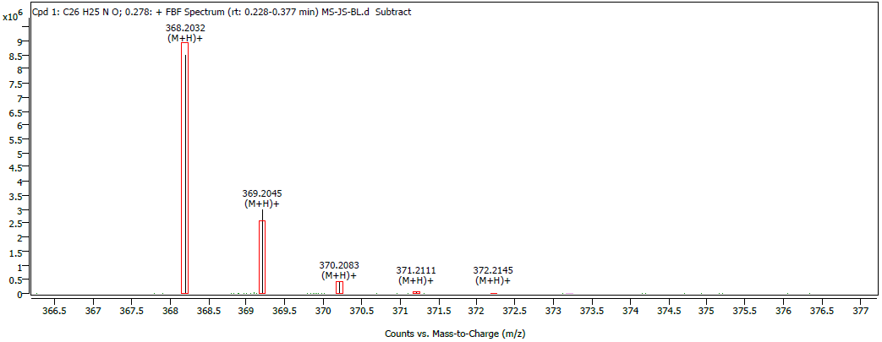

Figure S1. ESI-MS data of ligand L1 showing its isotropic pattern.

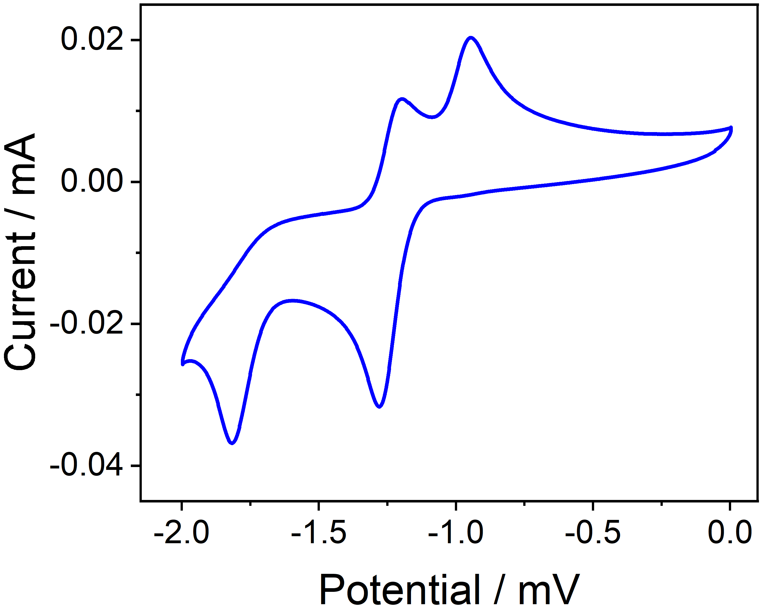

Figure S2: Cyclic Voltametric curve of reduction of ligand L1 against Fc⁺/Fc in 2mM solution in acetonitrile using glassy carbon as the working electrode, Fc⁺/Fc as the reference electrode, and platinum as the counter electrode with tetrabutyl ammonium tetrafluoro borate as the supporting electrolyte. The cyclic voltammogram displays two redox waves at E°₁,red = −1.28 mV and E°₂,red = −1.82 mV.

General procedure for the synthesis of compound Na(DME)₃[Fe(L1)₂] (1). 200 mg (0.542 mmol) of L1 was treated with 19.39 mg (0.843 mmol) of freshly-cut sodium in a 25 mL Schlenk tube containing 10 mL of THF. The mixture was stirred for about 24 hours. Then, anhydrous FeCl₂ (34.4 mg; 0.272 mmol) was added to this solution, and the stirring was continued for another 18 hours at room temperature. After completing the reaction, the solvent was removed under reduced pressure. The product of interest was extracted using diethyl ether (10 mL) and filtered. To the filtrate, 0.3 mL of dimethoxyethane (DME) was added before it was kept at room temperature for crystallization. Dark green, block-shaped single crystals of X-ray quality grew from the filtrate within one day. The yield of 1 (based on Fe²⁺) = 150 mg (59 %). Elemental analysis of 1: Calculated: C 70.9%, H 7.44%, N 2.58%, Found: C 70.86%, H 7.27%, N 2.20%.

Figure S3. Thermal ellipsoid picture of the asymmetric unit of 1. The hydrogen atoms are removed for clarity. Colour code: Magenta = Fe; Red = O, Blue = N and Grey = C, Green = Na.
Table S1. Crystallographic information of 1 at 100-300 K
 | 100 K | 150 K | 200 K | 250 K | 300 K
Empirical formula | C₆₄H₈₀N₂NaO₈Fe | C₆₄H₈₀N₂NaO₈Fe | C₆₄H₈₀N₂NaO₈Fe | C₆₄H₈₀N₂NaO₈Fe | C₆₄H₈₀N₂NaO₈Fe
Formula weight | 1084.14 | 1084.14 | 1084.14 | 1084.14 | 1084.14
Crystal system | Orthorhombic | Orthorhombic | Orthorhombic | Orthorhombic | Orthorhombic
Space group | P2₁2₁2₁ | P2₁2₁2₁ | P2₁2₁2₁ | P2₁2₁2₁ | P2₁2₁2₁
a/Å | 12.0187(7) | 12.0639(7) | 12.1448(1) | 12.1975(8) | 12.2513(9)
b/Å | 17.4500(1) | 17.4853(1) | 17.5597(1) | 17.6008(9) | 17.6433(9)
c/Å | 28.2484(1) | 28.3176(1) | 28.5190(1) | 28.6725(1) | 28.8189(1)
Volume/Å³ | 5924.4(6) | 5973.3(6) | 6081.9(7) | 6155.6(6) | 6229.3(6)
Z | 4 | 4 | 4 | 4 | 4
ρ_{calc} g/cm³ | 1.215 | 1.206 | 1.184 | 1.168 | 1.156
Crystal size/mm³ | 0.15 × 0.11 × 0.09 | 0.15 × 0.11 × 0.09 | 0.15 × 0.11 × 0.09 | 0.15 × 0.11 × 0.09 | 0.15 × 0.11 × 0.09
Radiation | Mo K_{α} (λ = 0.71073) | Mo K_{α} (λ = 0.71073) | Mo K_{α} (λ = 0.71073) | Mo K_{α} (λ = 0.71073) | Mo K_{α} (λ = 0.71073)
2Θ range for data collection/° | 3.682 to 50 | 3.67 to 49.996 | 3.646 to 49.988 | 3.628 to 66.118 | 3.612 to 66.032
Reflections collected | 53707 | 71121 | 54329 | 78128 | 78961
Independent reflections | 10442 | 10511 | 10711 | 19901 | 20151
R1 | 0.0576 | 0.0581 | 0.0629 | 0.0827 | 0.0939
wR2 | 0.1107 | 0.1059 | 0.0941 | 0.1154 | 0.1372
Flack parameter | 0.011(1) | 0.013(1) | 0.026(1) | 0.023(1) | 0.004(2)
Structural description of 1 (collected at 100 K).
As the iron atom is coordinated to the redox non-innocent ligand, therefore, determination of the oxidation state of the ligand is of utmost importance to accurately determine the electronic structure of 1. To determine the level of the reduction of L1 in 1, the structural parameters of the neutral, one, and two-electrons reduced L1 containing metal complexes were compared (see Scheme S3). As shown in Scheme S3, upon one-electron or two electrons reduction of neutral L1, the bond lengths of C-O and C-N increase while that of C-C bond length decreases gradually, compared to the neutral L1. However, the extent of bond distance increase (in C-O and C-N) or decrease (in C-C) is observed to be larger in two electrons reduction compared to the one-electron reduction of L1, as the additionally added electrons occupy the anti-bonding π* orbital of L1. In 1, the average C-O, C-N, and C-C bond distances were observed to be 1.328(6)Å, 1.395(7) Å, and 1.377(8) Å, respectively, which is consistent with the structural parameters observed for the two electrons reduced L1 (see Scheme S3).
Having two, 2-electron reduced ligands in 1 and the presence of one sodium cation (whose coordination sites were completed by three DME molecules) that resides in the crystal lattice unveils that the oxidation state of the iron is +3. At this juncture, we would like to point out that an additional electron that originates from the Fe^{II} precursor accounts for the overall two-electron reduction of each L1 in 1. The Fe-O and Fe-N bond lengths observed in 1 is also consistent with the other ferric ion complexes reported in the literature. ^{[1, 11]} As pointed out earlier, the geometry around the ferric ion was observed to be distorted square planar geometry, which is witnessed from the ∠O1-Fe-O2 (179.0°) and ∠N1-Fe-N2 (169.8°) bond angles (see Table S2 and Table S3).

Scheme S2. The general reaction scheme to isolate a five-coordinate Fe(III) complex [Fe(L1^{•-})₂Cl] by changing the reaction condition slightly from 1.
2
FeCl₃

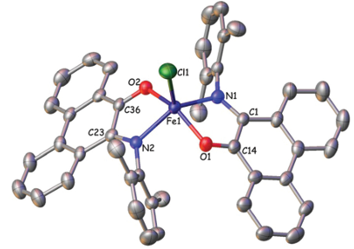

Figure S3A. Crystal structure of [Fe^{III}(L^{•-})₂Cl] complex.
The detailed analysis of the crystal structure of 1 reveals that all the four donor atoms (N₂O₂) are not co-planar, the dihedral angle observed within these donor atoms being 8.06° (see Table S2). Further, Fe(III) ion resides 0.079 Å above the average center of the plane formed by the N₂O₂ atoms. Such a distortion plays a detrimental role in determining the electronic structure of the complex, in particular the nature of the ground state. The shortest interatomic distance between the molecules in the crystal lattice of 1 was found to be 12.139(4) Å, and therefore, the intermolecular exchange interactions are expected to be extremely weak or nil. Also, it is observed that there are no π-π interactions existing in the crystal lattice of 1.
Table S2. Selected bond lengths and bond angles of 1 recorded at 100 K
Bond | Bond length/ Å | Bond angle | Bond angle/ º
Fe(1)-O(1) | 1.841(4) | O(1)-Fe(1)-N(1) | 84.77(1)
Fe(1)-O(2) | 1.852(4) | O(1)-Fe(1)-N(2) | 94.90(1)
Fe(1)-N(1) | 1.879(4) | O(1)-Fe(1)-O(2) | 178.89(1)
Fe(1)-N(2) | 1.873(4) | O(2)-Fe(1)-N(2) | 84.44(1)
C(1)-O(1) | 1.327(6) | O(2)-Fe(1)-N(1) | 96.04(1)
C(1)-C(2) | 1.389(8) | N(2)-Fe(1)-N(1) | 169.80(2)
C(2)-N(1) | 1.394(7) | Dihedral angle / º
C(2)-N(1) | 1.394(7) | O(1)-N(1)-O(2)-N(2) | 8.19
C(21)-O(2) | 1.330(6) | O(1)-Fe(1)-N(1)-O(2) | 179.23
C(21)-C(22) | 1.366(8) | O(1)-Fe(1)-N(2)-O(2) | 179.10
C(22)-N(2) | 1.396(7) | N(1)-Fe(1)-O(2)-N(2) | 169.74
Table S3 Continuous shape measure deviation (CShM) of 1
Structure | Deviation
SP-4 | 0.487
T-4 | 29.577
SS-4 | 16.154
vTBPY-4 | 31.109
SP = Square planar, T= Tetrahedral, SS= Sea saw, vTBPY= vacant trigonal bipyramidal
Scheme S3: Change in the structural parameters noticed upon various levels of reduction of the ligand L1 (neutral = black trace; 1e reduced = Blue trace; 2e reduced = green trace) along with the structural parameters observed for the L1 ligand (red trace) in complex 1. The data is taken from the Cambridge structural database where metal complexes using this ligand L1 is reported already.^{[1, 11]}

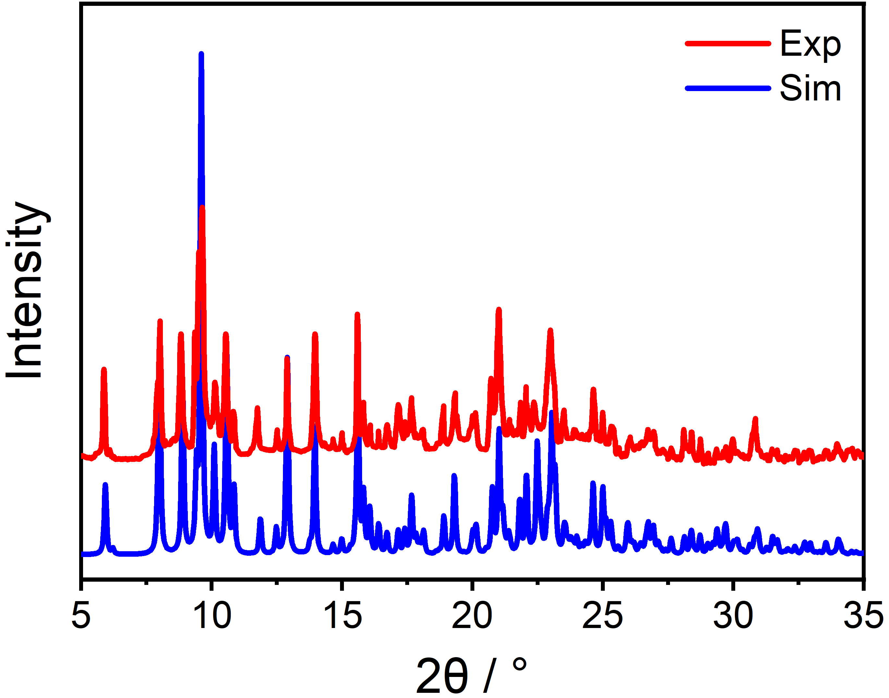

Figure S4: Powder X-ray diffraction pattern of the complex 1.

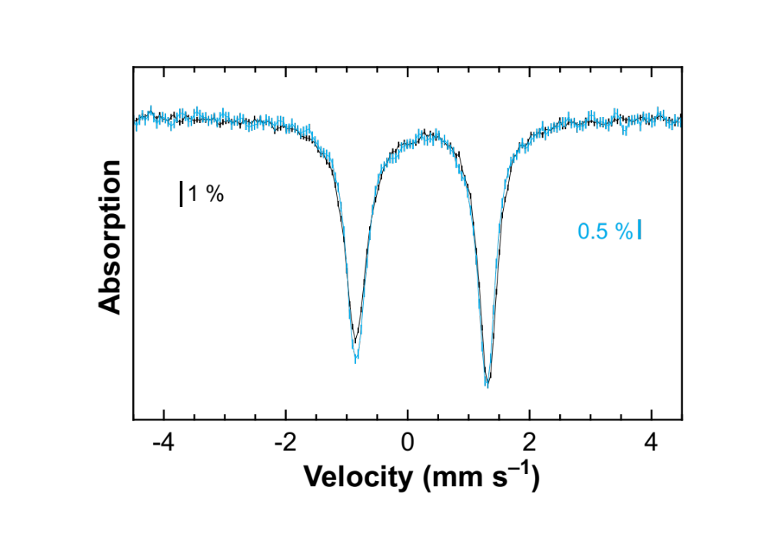

Figure S5. Superimposition of the zero-field experimental spectra of 1 recorded at ca 6 (black) and 80 K (blue) scaled to the same area.

Table S4. Linewidths and relative contributions of the slow- and fast-relaxing systems used to reproduce the Mössbauer spectra when assuming an effective spin of S=1/2.
 |  |  | Relative area (%)
T (K) | B (T) | Γ_{fwhm} (mm s^{–1}) | Slow | Fast
6 | 0ª | 0.466 / 0.378
6 | 0.06 | 0.453 | 27 | 73
6 | 1.0 | 0.472 | 61 | 39
6 | 4.0 | 0.432 | 100 | 0
6 | 7.0 | 0.429 | 100 | 0
80 | 0ª | 0.412 / 0.376
80 | 0.06 | 0.373 | 0 | 100
80 | 1.0 | 0.406 | 0 | 100
80 | 4.0 | 0.388 | 0 | 100
80 | 7.0 | 0.362 | 0 | 100
ª The zero-field spectra were simulated assuming a quadrupole doublet with two different linewidths.

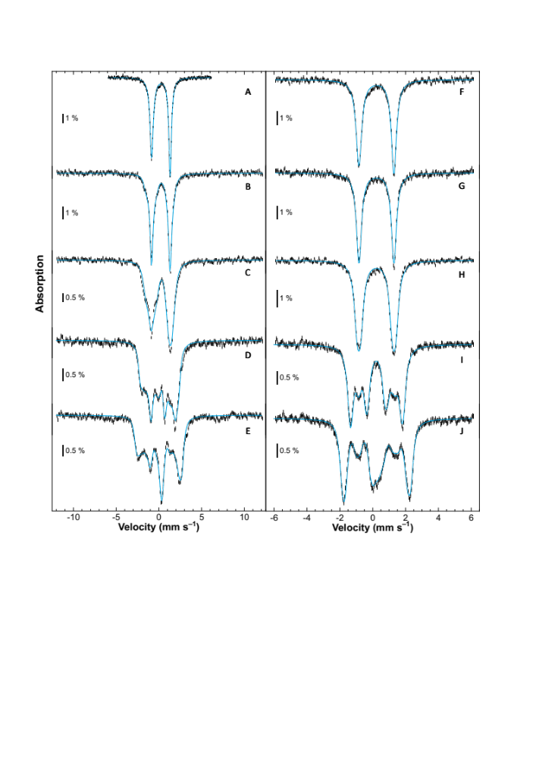

Figure S6. Experimental Mössbauer spectra recorded on a powder sample of 1 at ca 6 (A–E) and 80 K (F-J) at zero-field (A and F) or with a 0.06 (B and G), 1 (C and H), 4 (D and I) and 7 T (E and J) magnetic field applied parallel to the γ-rays (vertical bars). Simulations assuming an S=3/2 state and using the parameters listed in Table S5 and Table S6 are overlaid as solid blue lines. Theoretical spectra in panels A and E are identical to those shown in Figures 2A and 2E.

Table S5. Common electronic and nuclear parameters used to reproduce the 6 and 80 K spectra. An S=3/2 state was assumed.
δ (mm s^{–1}) | 0.23
∆E_{Q} (mm s^{–1})ª η | 2.16 / 2.13 0.74
Euler angles (°) (α, β, γ)^{b} | –35 0 0
D (cm^{–1}) E/D | 24 0
g_{k} (k = x, y, z)^{c} | 2.00 2.00 2.00
A_{k} / g_{n}µ_{n} (T) (k = x, y, z)^{d} | 6.0 –3.3 0.6
ª The quadrupole splitting is slightly lower at 80 K compared to that at 6 K.
^{b} Euler angles are those for the ZFS-tensor versus the EFG-tensor.
^{c} Fixed values.
^{d} The hyperfine tensor is colinear with ZFS-tensor.

Table S6. Linewidths and relative contributions of the slow and fast relaxing systems used to reproduce the Mössbauer spectra assuming a S=3/2 spin state.
 |  |  | Relative area (%)
T (K) | B (T) | Γ_{fwhm} (mm s^{–1}) | Slow | Fast
6 | 0ª | 0.466 / 0.378
6 | 0.06 | 0.436 | 30 | 70
6 | 1.0 | 0.532 | 63 | 37
6 | 4.0 | 0.444 | 100 | 0
6 | 7.0 | 0.438 | 100 | 0
80 | 0ª | 0.412 / 0.376
80 | 0.06 | 0.370 | 0 | 100
80 | 1.0 | 0.403 | 0 | 100
80 | 4.0 | 0.365 | 0 | 100
80 | 7.0 | 0.344 | 0 | 100
ªThe zero-field spectra were simulated assuming a quadrupole doublet with two different linewidths.

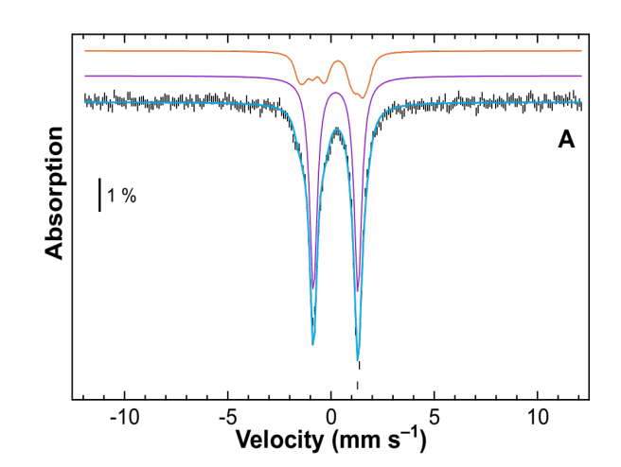
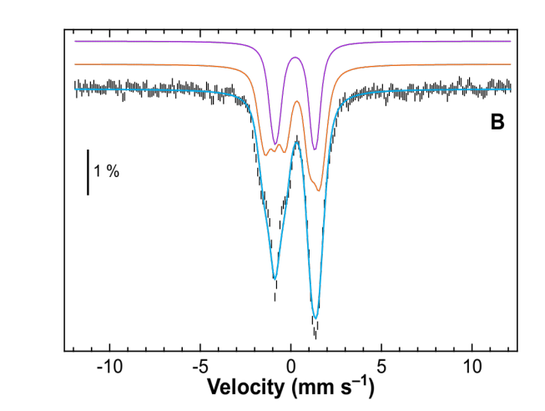

Figure S7. Experimental (vertical bars) of the ca 6 K Mössbauer spectra of 1 recorded with a 0.06 (A) and 1 T (B) external magnetic field applied parallel to the γ-rays. Simulations assuming an S=3/2 state are overlaid as solid blue lines (see Tables S5 and Table S6 for the parameters). The slow- and fast-relaxing contributions are displayed above the spectra as orange and purple lines, respectively.

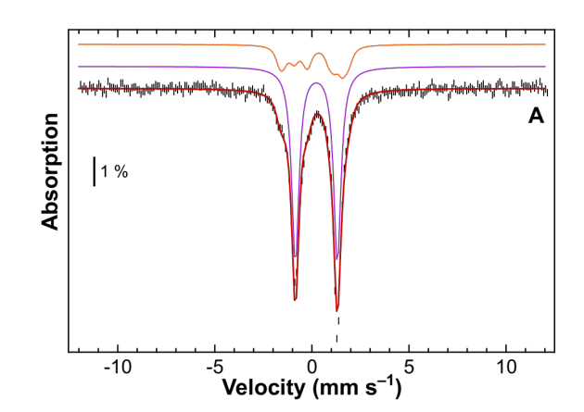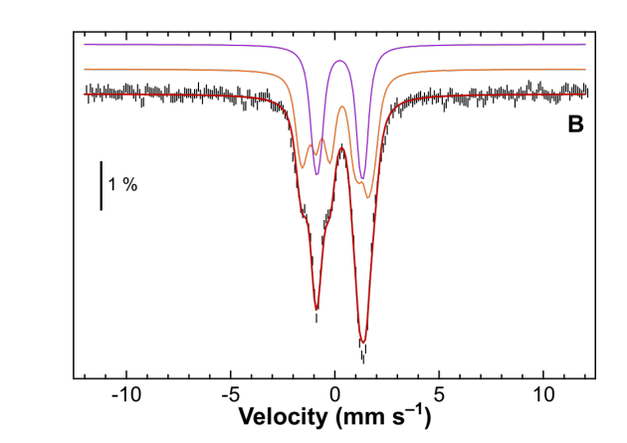

Figure S8. Experimental (vertical bars) of the ca 6 K Mössbauer spectra of 1 recorded with a 0.06 (A) and 1 T (B) external magnetic field applied parallel to the γ-rays. Simulations assuming an S=1/2 state are overlaid as solid red lines (see Tables 1 and Table S4 for the parameters). The slow- and fast-relaxing contributions are displayed above the spectra as orange and purple lines, respectively.
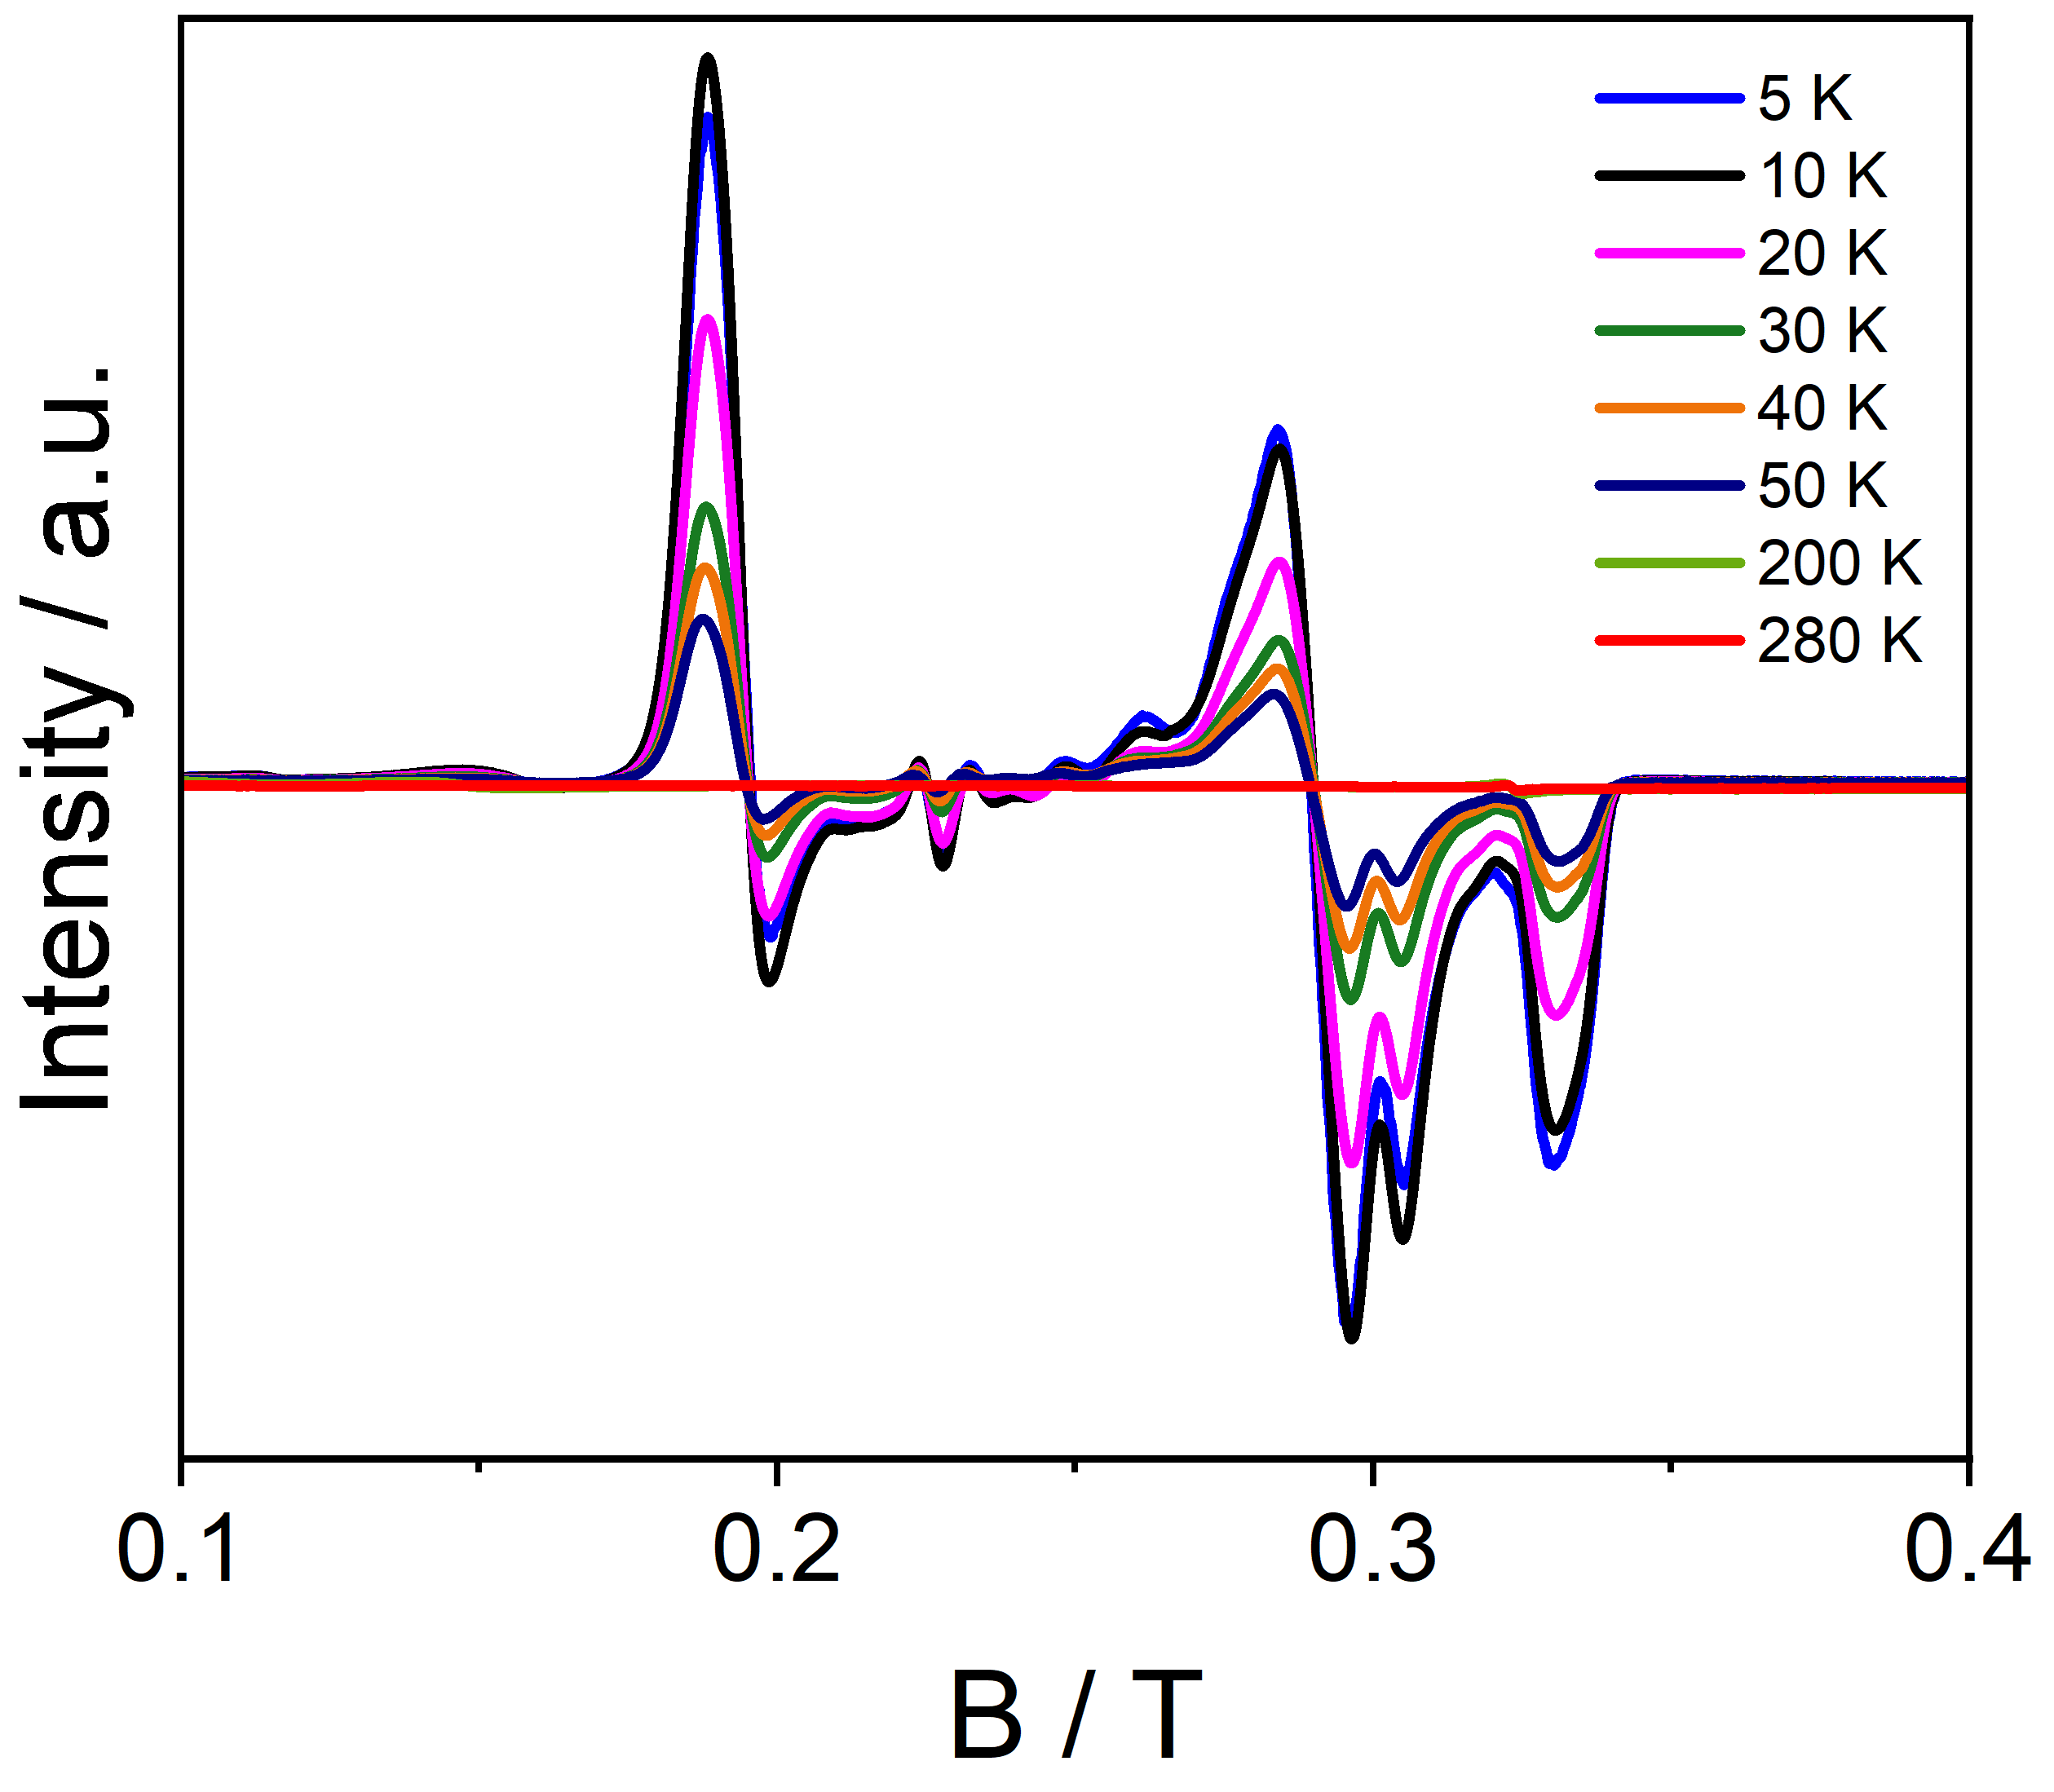

Figure S9. Variable temperature X-Band EPR for polycrystal sample of 1. Experimental conditions: frequency = 9.3842 GHz, modulation amplitude = 0.4 mT; microwave power = 2.518 mW, (attenuation = 19 dB).

Figure S10. The spin-crossover phenomenon observed in Fe(III) system in various coordination geometry. Octahedral (O_{h}), Square Pyramidal (Spy), Trigonal Bipyramidal (TBP), and Square Planar (SP).
Table S7. Selected bond length and bond angle of 1 collected in the temperature range 100-300 K
Bond length / Å | 150 K | 200 K | 250 K | 300 K
Fe1-O1 | 1.841(4) | 1.848(4) | 1.851(4) | 1.844(4)
Fe1-N1 | 1.875(4) | 1.884(5) | 1.889(5) | 1.888(5)
Fe1-O2 | 1.849(4) | 1.853(4) | 1.853(4) | 1.854(4)
Fe1-N2 | 1.873(5) | 1.883(5) | 1.883(5) | 1.895(5)
C1-O1 | 1.319(6) | 1.331(7) | 1.330(7) | 1.341(7)
C2-N1 | 1.393(6) | 1.394(7) | 1.395(6) | 1.399(7)
C1-C2 | 1.384(8) | 1.376(9) | 1.379(8) | 1.377(9)
C21-O2 | 1.319(6) | 1.336(7) | 1.325(6) | 1.338(7)
C22-N2 | 1.394(6) | 1.393(7) | 1.403(7) | 1.396(7)
C21-C22 | 1.385(7) | 1.391(8) | 1.392(8) | 1.382(9)
Bond angle / ° | 150 K | 200 K | 250 K | 300 K
O1-Fe1-O2 | 179.16(1) | 179.60(2) | 179.70(2) | 179.8(2)
O1-Fe1-N1 | 84.47(1) | 84.40(2) | 84.33(2) | 84.50(2)
O1-Fe1-N2 | 94.82(1) | 95.10(2) | 95.40(2) | 95.30(2)
O2-Fe1-N1 | 96.33(1) | 96.00(2) | 95.90(2) | 95.70(2)
O2-Fe1-N2 | 84.42(1) | 84.53(1) | 84.43(2) | 84.60(2)
N1-Fe1-N2 | 170.00(2) | 170.20(2) | 170.50(2) | 171.00(2)
Dihedral angle / °
O(1)-N(1)-O(2)-N(2) | 7.71 | 7.40 | 7.23 | 6.77
O(1)-Fe(1)-N(1)-O(2) | 179.77 | 179.97 | 179.78 | 180.00
O(1)-Fe(1)-N(2)-O(2) | 179.84 | 179.91 | 179.75 | 179.97
N(1)-Fe(1)-O(2)-N(2) | 170.00 | 170.17 | 170.50 | 170.91

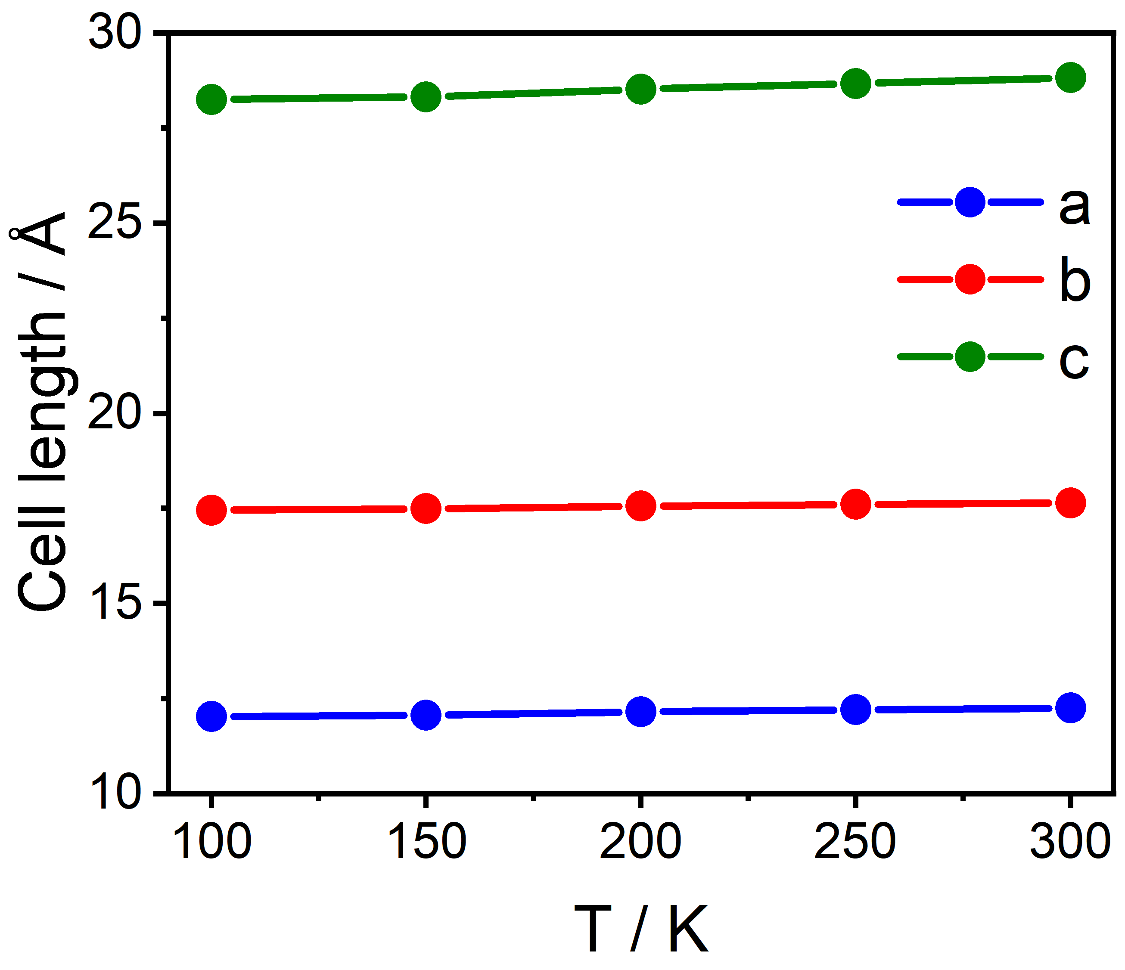

Figure S11. The unit cell parameters in 1 as a function of temperature.

Figure S12. The optimized geometry of sextet (left), quartet (middle) and doublet (right) spin state of 1. Colour code: Fe-brown, O-red, N-blue, C-grey. Hydrogens are omitted for clarity.

Table S8. Benchmarking of different functionals for complex 1, comparing the energies of S=5/2, 3/2, and 1/2 spins.
Functional | Energy (kJ/mol)
Functional | S=5/2 | S=3/2 | S=1/2
B3LYP | 25.6 | 0 | 5.4
BP86 | 4.1 | 0 | 0.5
TPSSh | 50.1 | 0 | 3.3
TPSS | 53.3 | 0 | 2.6

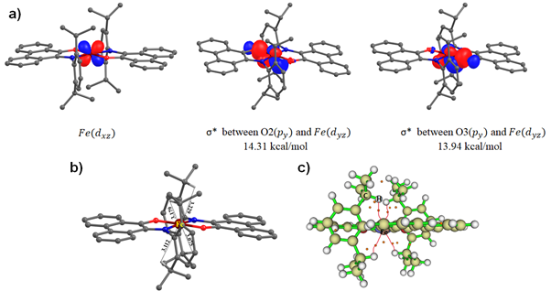

Figure S13. a) d_{xz} orbital (left) of Fe metal center having no second-order perturbation interaction with attached ligand atoms, d_{yz} orbital of Fe metal center having two σ antibonding interactions with two oxygen atoms (middle and right), b) Optimised structure of quartet showing non-covalent interactions between C-H•••Fe bond, c) AIM plot for 1 showing Bond critical points by red spheres.

Table S9. The optimized structural parameters of 1 for sextet, quartet and doublet spin states. See Figure S12 for atom labelling.
Optimized structural parameters | Sextet | Quartet | Doublet
Fe1-O2 (Å) | 1.924 | 1.863 | 1.890
Fe1-O1 (Å) | 1.924 | 1.863 | 1.890
Fe1-N1 (Å) | 1.997 | 1.930 | 1.928
Fe1-N2 (Å) | 1.997 | 1.930 | 1.928
O2-Fe1-N1 (°) | 116.5 | 96.9 | 97.0
N1-Fe1-O1 (°) | 84.0 | 83.1 | 83.0
O1-Fe1-N2 (°) | 116.2 | 96.9 | 97.0
N2-Fe1-O2 (°) | 84.0 | 83.1 | 83.0

Figure S14. The spin density (iso-surface value 0.006 e⁻/bohr³) of sextet (left), quartet (middle) and doublet (bottom) spin state of 1. Colour code: Fe-brown, O-red, N-blue, C-grey. Hydrogens are omitted for clarity.
Table S10 The spin density values of Fe and its first coordination sphere atoms in 1 for sextet, quartet and doublet spin states. See Figure S12 for atom labelling.
Atom | Sextet | Quartet | Doublet
Fe | 4.030 | 2.542 | 1.849
O2 | 0.176 | 0.054 | -0.088
N1 | 0.191 | 0.092 | -0.210
O1 | 0.176 | 0.054 | -0.087
N2 | 0.190 | 0.091 | -0.210

Table S11. Benchmarking of different functionals for the S = 3/2 state in complex 1 to calculate the Mössbauer parameter, isomer shift (δ).

Functional | α | β | C | δ(opt) | δ(xray)
B3LYP | -0.366 | 2.852 | 11810 | 0.26 | 0.20
BP86 | -0.425 | 7.916 | 11810 | 0.25 | 0.17
TPSSh | -0.376 | 4.130 | 11810 | 0.20 | 0.15
TPSS | -0.421 | 5.154 | 11810 | 0.27 | 0.19

Table S12. Relative Energies (in eV) of Fe orbitals with different functionals for quartet state of complex 1.
Orbitals | B3LYP | BP86 | TPSSh | TPSS
d_{xz} | 0 | 0 | 0 | 0
d_{z2} | 0.23 | 0.56 | 0.18 | 0.15
d_{xy} | 0.27 | 0.59 | 0.21 | 0.33
d_{yz} | 0.73 | 0.65 | 2.60 | 0.43
d_{x2-y2} | 2.26 | 3.50 | 4.67 | 3.49

Table S13. The CAS(7,6)SCF/NEVPT2 transition energy of the ligand field states of 1.
Complex 1 | NEVPT2 energy levels
States | Energy (cm⁻¹)
⁴T₁ | 0.0  4171.5  6468.5
²E | 3187.2  6449.4
⁶A₁ | 7582.2
⁴T₂ | 7629.2  8974.2  9930.9
⁴E | 11607.1  13929.0
²A₂ | 13177.0

Table S14. The major electronic configurations of the first nine states from the
CAS(7,6)SCF/NEVPT2 calculations on 1.
State | 2S+1 | Energy (cm⁻¹) | Major electronic configuration | %
1 | 444 | 00.00 | (π_{L})¹(dz²)²(d_{yz})¹(d_{xy})²(d_{xz})¹d_{y} | 61.66
2 | 2 | 3187.2 | (π_{L})²(dz²)²(d_{yz})¹(d_{xy})² | 60.8
3 | 4 | 4171.5 | (π_{L})¹(dz²)¹(d_{yz})²(d_{xy})²(d_{xz})¹ | 84.0
4 | 2 | 6449.4 | (π_{L})²(dz²)¹(d_{yz})²(d_{xy})² | 83.3
5 | 4 | 6468.5 | (π_{L})²(dz²)¹(d_{yz})¹(d_{xy})²(d_{xz})¹ | 43.4
6 | 6 | 7582.2 | (π_{L})²(dz²)¹(d_{yz})¹(d_{xy})²(d_{xz})¹(d_{x2-y2})¹ | 99.6
7 | 4 | 7629.2 | (π_{L})²(dz²)²(d_{yz})¹(d_{xy})¹(d_{x2-y2})¹ | 50.9
8 | 4 | 8974.2 | (π_{L})²(dz²)²(d_{yz})¹(d_{xy})¹(d_{xz})¹ | 52.7
9 | 4 | 9930.9 | (π_{L})²(dz²)¹(d_{yz})²(d_{xy})¹(d_{xz})¹ | 63.6

References:
[1] B. Xu, A. Ma, T. Jia, Z. Hao, W. Gao, Y. Mu, Dalton Trans., 2016, 45, 17966-17973.
[2] a) G. M. Sheldrick, C.J. Gilmore, H. A. Hauptman, C. M. Weeks, R. Miller, I. Usón, 2012; b) G. Sheldrick, Acta Crystallogr. Sect. A 2008, 64, 112-122; c) O. V. Dolomanov, L. J. Bourhis, R. J. Gildea, J. A. K. Howard, H. Puschmann, J. Appl. Crystallogr. 2009, 42, 339-341.
[3] a) M. Carboni, M. Clémancey, F. Molton, J. Pécaut, C. Lebrun, L. Dubois, G. Blondin, J. M. Latour, Inorg. Chem. 2012, 51, 10447-10460; b) C. Charavay, S. Segard, F. Edon, M. Clémancey, G. Blondin, CEA/DRF/BIG, CNRS, Université Grenoble-Alpes Search PubMed 2012.
[4] a) M. A. Hemminga, L. J. Berliner, Biological magnetic resonance 2007, 27; b) S. Stoll, A. Schweiger, J. Magn. Reson. 2006, 178, 42-55.
[5] M. J. Frisch, G. W. Trucks, H. B. Schlegel, G. E. Scuseria, M. A. Robb, J. R. Cheeseman, G. Scalmani, V. Barone, B. Mennucci, G. A. Petersson, See also: URL: http://www. gaussian. com 2009, 620.
[6] F. Weigend, R. Ahlrichs, Phys. Chem. Chem. Phys. 2005, 7, 3297-3305.
[7] F. Neese, WIREs Comput. Mol. Sci. 2012, 2, 73-78.
[8] S. Roy Chowdhury, S. Mishra, J. Chem. Phy. 2018, 149, 234302.
[9] C. Angeli, R. Cimiraglia, S. Evangelisti, T. Leininger, J. P. Malrieu, J. Chem. Phy. 2001, 114, 10252-10264.
[10] R. Maurice, R. Bastardis, C. d. Graaf, N. Suaud, T. Mallah, N. Guihéry, J. Chem. Theory Comput. 2009, 5, 2977-2984.
[11] a) N. Roy, S. Sproules, E. Bill, T. Weyhermüller, K. Wieghardt, Inorg. Chem. 2008, 47, 10911-10920; b) M. Fang, S. R. Wilson, K. S. Suslick, J. Am. Chem. Soc. 2008, 130, 1134-1135; c) S. Zhang, Q. Wang, L. M. Thierer, A. B. Weberg, M. R. Gau, P. J. Carroll, N. C. Tomson, Inorg. Chem. 2019, 58, 12234-12244.

